Java Team Member Onboarding Kit

Document Revision History

|  |  |  |  |  |  |
| --- | --- | --- | --- | --- | --- |
| **Change Request#** | **Document Version** | **Approval Date** | **Modified By** | **Section, Page(s) and Text Revised** | **Approved By** |
| 1 | Draft |  |  |  |  |

**Template Revision History**

|  |  |  |  |  |  |
| --- | --- | --- | --- | --- | --- |
| **Change Request#** | **Document Version** | **Approval Date** | **Modified By** | **Section, Page(s) and Text Revised** | **Approved By** |
| BEOPS-281 | 1.0 | 20 Oct- 2010 | Karthika Nair H | Initial version | Meenakshi S |
| BEOPS-432 | 1.1 | 14-Feb-2011 | Saloni Srivastava | Created Initial Version | Radhika Rani |
| BEOPS-743 | 1.2 | 26 April 2012 | Adini S | ALL – Template revamped | Krishnapuram Krishna |
| BEOPE-916 | 1.3 | 03-Oct-2012 | Pravin David | TOC | Krishnapuram Krishna |
| BEOPS-1287 | 1.4 | 25-Sep-2013 | Pravin David | Revisited the templates to reduce the document size | Krishnapuram Krishna |
| BEOPS-1458 | 1.5 | 16-Oct-2013 | Thripurasundari R | Section 4.5 updated to provide placeholder for updating the limitations of the COTs module | Krishnapuram Krishna |
| BEOPS-1752 | 1.6 | 28-Feb-2014 | Pravin David | Amended to align it to the corporate template | Krishnapuram Krishna |
|  |  |  |  |  |  |

**Note: Template Revision History can be found in Hidden Text.**

Table of Contents

Document Revision History 2

Table of Contents 3

1. Introduction 4

1.1. Purpose of this Document 4

1.2. Definitions Acronyms and Abbreviations 4

2. Required List of Software’s. 4

3. Installation of Software’s. 6

3.1 Database Setup. 6

3.2 Sonar Lint installation. 8

3.3 JAVA and Maven Installation. 8

3.4 JAVA Certificate installation and Git Clone. 8

4. Azure DevOps Access. 8

5. ID Creation. 8

5.1 GIT HUB ID Creation. 8

5.2 Sonar Cloud ID Creation. 8

5.3 Ardonagh ID Creation. 8

6. KT Recordings. 9

6.1 Functional KT Recordings. 9

6.2 Technical KT Recordings. 9

1. Introduction
   1. Purpose of this Document

This document will be facilitating the Java team members onboarding and helping him to get settled in project in minimum time.

* 1. Definitions Acronyms and Abbreviations

| **Term** | **Description** |
| --- | --- |
| Auth0 | Authentication token provider used in Ardonagh enterprise landscape. |
| JWT | JSON Web token. |
| GXB | Global XB |
| AS | Ardonagh Specialty |
| DMS | Document Management Service |
| BPM | Business Process Modelling |
| TBD | To Be Done |
| TBC | To Be Completed |

1. Required List of Software’s.

Below is list of required software’s and its installation process

1. JDK 11.7.
2. Apache Maven 3.8.1
3. Visio (Optional and needed for Leads and Above)
4. STS 4.4 (https://spring.io/tools)
5. eclipse 4.0
6. Notepad ++
7. 7 Zip
8. Citrix
9. Git Version 2.30.2.2 ( <https://git-scm.com/download/win> )
10. Azure data studio
11. Mozilla / Chrome
12. Microsoft SQL Server Management Studio (SSMS) can be downloaded from below link

<https://docs.microsoft.com/en-us/sql/ssms/download-sql-server-management-studio-ssms?view=sql-server-ver15>

You need to raise Software installation request on EASe+ for the above software for which URL is not present.

|  |
| --- |
| **Software Provision Request Details** |

|  |  |
| --- | --- |
| Request Number | REQxxxxxxxxx |
| Request Item Number | RITM0054331 |
| Requested By | Shrikant Kulkarni |
| Requestor Employee ID | 2442282 |
| Requested For | Shrikant Kulkarni |
| Project Name | 104397_Ardonagh_Specialty_Apps |
| Project Code | 104430 |
| Software Category | Freeware/Open Source |
| Software Publisher | Oracle |
| Software Name | Java SE 11.0 (OpenJDK) |
| Location | mph-cybercity tower 4 pune,in |
| Hostname | LTPPUN022442282 |
| Description/Justification | Need below software’s along with Java SE 11.0 (JDK) STS 4.4 , eclipse 4.0 , Notepad ++ , 7 Zip, Citrix, Git Version 2.30.2.2 , Azure data studio, Mozilla / Chrome, Maven. |
| Status | Work in progress |

In order to install these soft’sware we will need **Admin Rights**. We need to raise request in EASe+ as per latest security policies. IT team had stopped giving the user level Admin Rights and providing the Application-level Admin Rights for which Level 9 approval is required. So we need to get the approval from Malik ([mallikarjun.hs@mphasis.com](mailto:mallikarjun.hs@mphasis.com)) , please find attached sample mail –



Request ticket is created and has been assigned to respective support team.

|  |  |
| --- | --- |
| **Ticket Number** | REQXXXXXX |
| **Request For** | Shrikant Kulkarni |
| **Opened By** | Shrikant Kulkarni |
| **Cubicle Number** | L000000 |
| **Contact Number** | 9970944645 |
| **Account / Department** | MphasiS Apps - Government 1.2 |
| **Short Description** | New system admin access |
| **Description** | Need admin rights on newly issued laptop. |
| **State** | Open |

Apart from this sometime your Laptop/desktop host name doesn’t reflect on the EASe+ and you need to raise an incident for same so that IT team works on it post the Host name is reflected you can raise software request on EASe+

|  |  |
| --- | --- |
| **Ticket Number** | INCXXXXXXXXX |
| **Ticket Creation Time** | 2021-05-26 13:29:53 IST |
| **State** | Open |
| **Priority** | P4 |
| **Short Description** | Host name does not display in EASe+ while raising software request |
| **Description** | My hostname is not reflecting on EASe+ so not able to raise request for software. |
| **Assignment Group** | IT-Helpdesk |

1. Installation of Software’s.
   1. Database Setup.

Once Microsoft SQL Management Studio is installed, you need to setup the Database using below parameters

**DB Server Name** - sql-prjson-pf-digital-dev.database.windows.net

**Username –** prjson_readwrite

**Password:** Mphasis123

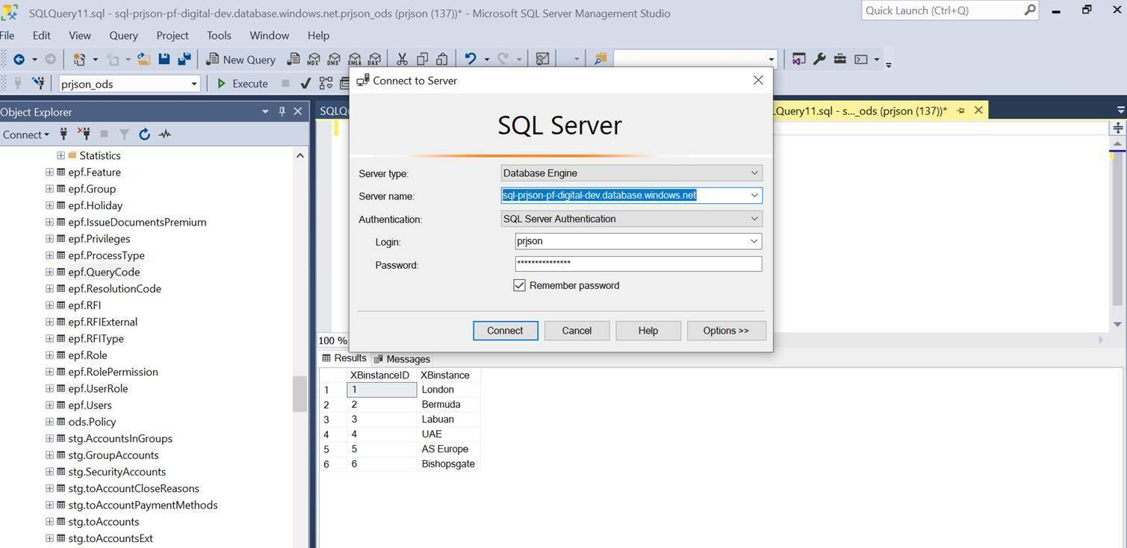  
  
Once you can connect you should be able to see tables as shown in below screenshot.

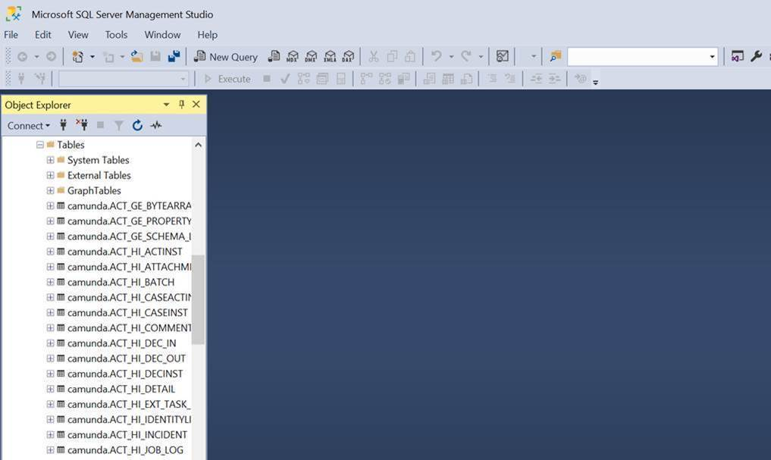

* 1. Sonar Lint installation.

Sonar Lint plugin must be installed in Eclipse STS.

Please find the instructions here 

**NOTE:** Please follow the below instructions if facing any errors in Eclipse marketplace



* 1. JAVA and Maven Installation.

Please refer this document for Java and Maven installation. 

3.4 JAVA Certificate installation and Git Clone.

Please search for keywords JAVA and GIT in this file **NS_SSL_V5.0.pdf** and follow the instructions.

**NOTE:** You should be having admin access.



1. Azure DevOps Access.

Please contact your leads for the Azure DevOps Access.

1. ID Creation.

5.1 GIT HUB ID Creation.

GIT Hub access will be automatically enabled once Azure DevOps access is enabled.

5.2 Sonar Cloud ID Creation.

Sonar cloud access is for LEVEL – 6 and above.

If your LEVEL is 6 and above, please contact your leads for the same.

5.3 Ardonagh ID Creation.

Please request Shripad Naik for Ardonagh ID Creation [[Shripad Naik](mailto:Shripad.Naik@mphasis.com?subject=Ardonagh%20ID%20Creation)].

Immediately change the password, once the credentials are received.

6. KT Recordings.

6.1 Functional KT Recordings.

Functional KT recording is available [**HERE**](https://mphasis.sharepoint.com/sites/PriceForbes/Shared%20Documents/General/Induction%20and%20Training/Domain%20Training/KT%20-%20Functional%20background%20on%20IBA%20and%20PP%2023.12.20.mp4)

6.2 Technical KT Recordings.